|  |
| --- |
| **Digital Logic Design**  **(EL-1005)** |
| **LABORATORY MANUAL**  **Spring-2025** |



|  |  |  |  |  |
| --- | --- | --- | --- | --- |
| **LAB 03**  **Advance Logic Gate and Boolean Algebra** | | | | |
|  | |  | |  |
| ________________________________________ | | __________ | | ___ |
| STUDENT NAME | | ROLL NO | | SEC |
|  | | | | |
| ______________________________________ | | | | |
| INSTRUCTOR SIGNATURE & DATE | | | | |
| **MARKS AWARDED: /10** | | | | |
| ___________________________________________________________________ | | | | |
| **NATIONAL UNIVERSITY OF COMPUTER AND EMERGING SCIENCES (NUCES), KARACHI** | | | | |
|  | | | | |
|  |  |  |  | |

**Lab Session 03: Advance Logic Gate and Boolean Algebra**

**OBJECTIVES:**

The objectives of this lab is:

* Investigate the logical properties of exclusive-OR, exclusive-NOR function and implement it using basic and universal gates.
* To utilize the fundamental operations of Boolean algebra in logic circuit measurements.

**APPARATUS:**

* Logic trainer
* Logic probe

**COMPONENTS:**

ICs 74LS02, 74LS00 , 74LS08, 74LS32, 74LS04 , Jumper Wire

**Introduction:**

Secondary gates can be made by the combinations of primary and universal gates. There are two types of secondary gates which may be termed as advanced gates,

1. The XOR Gate.
2. The XNOR Gate.
3. **The Exclusive-OR Gate (XOR Gate):**

The exclusive OR function is an interesting and useful logical operation. As the name implies, it is similar to the previously studied OR function, but it’s a new and distinct operation. **"It is a device whose output is 1 only when the two inputs are different, but 0 if the inputs are the same."** This is useful for comparator circuits; if the inputs are different, then the output will be true, otherwise it is false. **The symbol for exclusive-OR function is  and the logical expression is shown in fig below.**

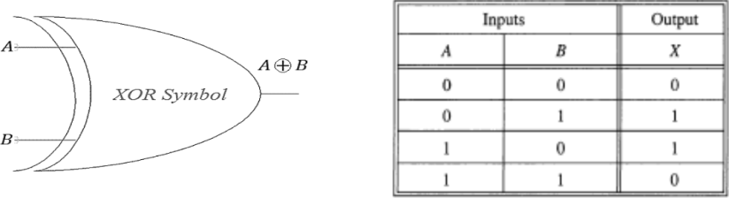**Symbol:**

Figure 2 Exclusive-OR Gate Symbol

**Function Table:**

|  |  |  |
| --- | --- | --- |
| **Inputs** | | **Output** |
| **A** | **B** | **Y** |
| L | L | L |
| L | H | H |
| H | L | H |
| H | H | L |

Table: 1 XOR Gate Truth Table

H= Logic High, L= Logic Low

#### **Connection Diagram:**

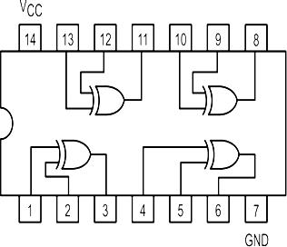7486 IC contains four 2-input XOR gates. The connection diagram for this IC are shown below:

Figure 2 XOR Gate Connection diagram

The XOR gate can be implemented by using primary and universal gates as follows

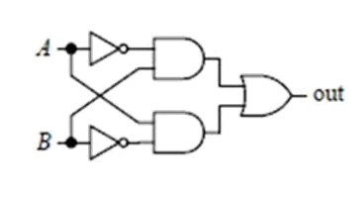

A B = A'B+AB'

Figure 3 XOR Gate using basic Gate

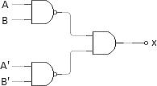

A B = (AB)'.(A'B')'=(AB)'.A+B

Figure 4 XOR Gate using universal Gates

1. **Exclusive-NOR Gate (XNOR)**

An XNOR gate (sometimes referred to as Exclusive NOR gate) is a digital logic gate with two or more inputs and one output that performs logical equality. **The output of an XNOR gate is 1 when all of its inputs are same. If some of its inputs are 1 and others are 0, then the output of the XNOR gate is 0.**

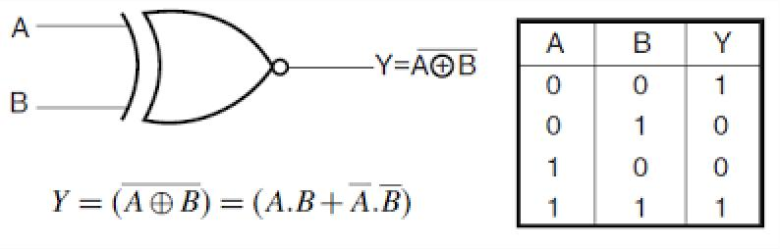**Symbol:**

Figure 5 Exclusive-NOR Gate Symbol

**Function Table:**

|  |  |  |
| --- | --- | --- |
| **Inputs** | | **Output** |
| **A** | **B** | **Y** |
| L | L | H |
| L | H | L |
| H | L | L |
| H | H | H |

Table: 2 XNOR Gate Truth Table

H= Logic High, L= Logic Low

#### **Connection Diagram:**

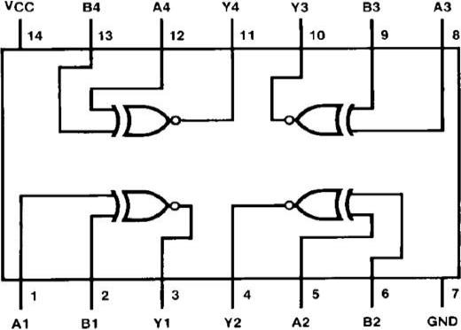74266 IC contains four 2-input XOR gates. The connection diagram for this IC are shown below:

Figure 6 XNOR Gate Connection diagram

XNOR Gate can also be implemented by using primary gates as follows.

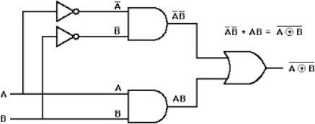

Figure 7 XNOR Gate implementation using primary gate

**Boolean Algebra:**

When a Boolean expression is implemented with logic gates, each term requires a gate, and each variable within the term designates an input to the gate. **Boolean algebra is applied to reduce an expression for obtaining a simpler circuit.** A Boolean function can be written in a variety of ways when expressed algebraically. There are, however, a few ways of writing algebraic expressions that are considered to be standard forms.

The standard forms contain product terms and sum terms. An example of a product term is XYZ. This is a logical product consisting of an AND operation among three literals. An example of a sum term is X+Y+Z. This is a logical sum consisting of OR operation among the literals.

**Rules and Law of Boolean Algebra:**

1. **Commutative law**

Commutative law states that the inter-changing of the order of operands in a Boolean equation does not change its result.

1. Using OR operator → A + B = B + A
2. Using AND operator → A * B = B * A

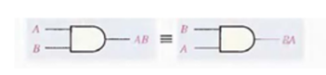

Figure 8 Commutative law in AND Gate

### Associative Law

### Associate Law of Addition:

### Associative law of addition states that OR more than two variables i.e. mathematical addition operation performed on variables will return the same value irrespective of the grouping of variables in an equation. It involves in swapping of variables in groups. The Associative law using OR operator can be written as

A+(B+C) = (A+B)+C

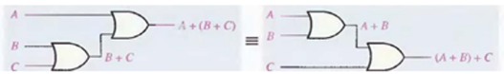

Figure 9 Application of Associative law of addition

#### **Associate Law of Multiplication**

#### Associative law of multiplication states that AND more than two variables i.e. mathematical multiplication operation performed on variables will return the same value irrespective of the grouping of variables in an equation. The Associative law using AND operator can be written as

#### A * (B * C) = (A * B) * C

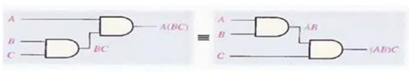

Figure 10 Application of Associative law of Multiplication

### Distributive law

### This is the most used and most important law in Boolean algebra, which involves in 2 operators: AND, OR. The multiplication of two variables and adding the result with a variable will result in same value as multiplication of addition of the variable with individual variables. Distributive law can be written as

A + BC = (A + B) (A + C)

This is called OR distributes over AND.

The addition of two variables and multiplying the result with a variable will result in same value as addition of multiplication of the variable with individual variables. Distributive law can be written as

A (B+C) = (A B) + (A C)

This is called AND distributes over OR.

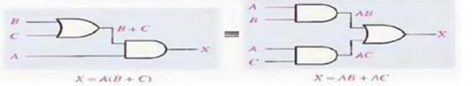

Figure 11 Application of Distributive law of Multiplication over addition and vice-versa

**IN-LAB**

**Lab Task#01:** For the Boolean function do the following:



Draw logic circuit diagram in the space provided below and implement the circuit on logic trainer.

Draw timing diagrams for construction and verification of the circuit

|  |  |  |
| --- | --- | --- |
| Inputs | A |  |
| B |  |
| C |  |
| Output | F2(expected result) |  |
| F2(implementation  result) |  |

#### **Lab Task#02:**



 Write the Boolean expression for the logic circuit in Figure 01. Also implement the given circuits on trainer and draw Truth tables:

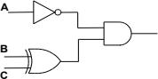

Figure 01: Combinational Circuit

**POST-LAB**

#### **Lab Task#1:**

For the Boolean function do the following:



Draw logic circuit diagram in the space provided below. Also write the Truth Table.

Draw timing diagrams for construction and verification of the circuit. (Hint: You can use LogicWorks).

|  |  |  |
| --- | --- | --- |
| Inputs | A |  |
| B |  |
| C |  |
| D |  |
| Output | F1(expected result) |  |
| F1(implementation  result) |  |

**Task 2:**

Prove that the circuits are equal via the laws mentioned above and via the logic trainer. Make sure to only create both circuits.

1. **A + AB = A**
2. **(A + B) (A + C) = A + BC**

**Task 3:**

Implement the mentioned logic using only two XOR gates.

